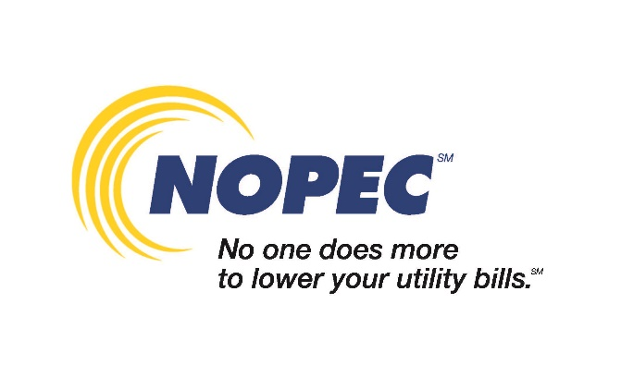

COPY FOR USE ON WEBSITES OR WATER BILL INSERTS  
*Please include NOPEC logo and link to:* <https://www.nopec.org/>. *Please fill in the copy in red with your community’s individual information.*

(Community Name) is a member of NOPEC’s (natural gas, electric, natural gas and electric) aggregation program(s). NOPEC is a group of 240 Ohio communities that negotiates exclusive electricity and natural gas rates for eligible residents and small businesses in NOPEC member communities. Since 2001, NOPEC has saved customers hundreds of millions of dollars on their energy costs, provided education opportunities for Ohio students and residents, and helped protect Ohio energy consumers by advocating for consumer-friendly energy policies to protect against unfair utility rate increases. For more information, visit [nopec.org](https://www.nopec.org) or call their 24/7 Customer Care Center at 855-667-3201.

p